Jahangirnagar University
Institute of Information Technology
Savar, Dhaka-1342

Lab report - 05
DNS and Web Server Configuration

Course: Computer Networks Lab
Course Code: ICT-3104

Submitted To
Jesmin Akhter, PhD
Professor, Institute of Information Technology
Submitted By
Md. Shaon Khan
ID: 1984 Batch: 52 Session: 2022–2023

Date of Submission
20 July 2026

1. Objective
The objective of this lab is to design and configure a small enterprise-style network in Cisco Packet Tracer consisting of a router, two switches, a PC, two web servers, and a DNS server. The router is configured with two subinterfaces so that each switch sits on its own subnet, the DNS server is configured with an A record mapping a domain name to a web server's IP address, and the PC is used to verify that the web page can be reached by typing the domain name (www.shaon.com) into a web browser instead of a raw IP address.

2. Setup
The topology uses one Cisco 2811 router (Router0) connected to two Cisco 2960-24TT switches. Switch0 connects the router to PC0 on the 192.168.1.0/24 network. Switch1 connects the router to Server0 (Web Server) and Server1 (DNS Server) on the 192.168.2.0/24 network. The devices and interfaces used are summarised below.
Device | Role / Connected Interface
Router0 (2811) | Fa0/0 → Switch0, Fa0/1 → Switch1
Switch0 (2960-24TT) | Fa0/2 → Router0, Fa0/1 → PC0
Switch1 (2960-24TT) | Fa0/1 → Router0, Fa0/2 → Server1, Fa0/3 → Server0
PC0 | 192.168.1.0/24 network (behind Switch0)
Server0 | Web Server – 192.168.2.0/24 network (behind Switch1)
Server1 | DNS Server – 192.168.2.0/24 network (behind Switch1)

3. Network Diagram (draw.io)
The logical diagram below, produced in draw.io, illustrates the intended design before it was built in Packet Tracer: a router connecting two switches, with a PC on one branch and the DNS server plus two web servers on the other branch.
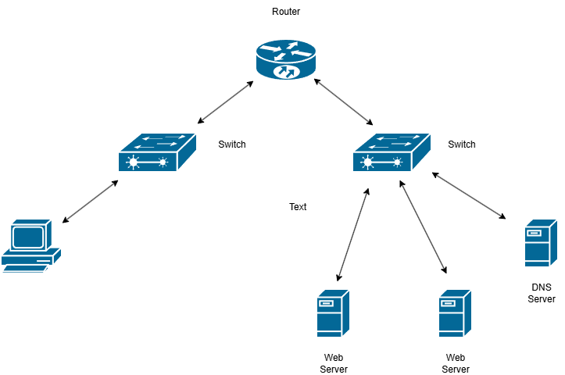
Figure 1: Logical network diagram (draw.io)

4. Router CLI Configuration
Router0 was configured from the CLI to bring up both FastEthernet interfaces and assign each one an IP address on its respective subnet, so that it could route between the PC network and the server network.
Router>enable
Router#configure terminal
Enter configuration commands, one per line. End with CNTL/Z.
Router(config)#interface fa0/0
Router(config-if)#no shutdown

Router(config-if)#
%LINK-5-CHANGED: Interface FastEthernet0/0, changed state to up
%LINEPROTO-5-UPDOWN: Line protocol on Interface FastEthernet0/0, changed state to up
Router(config-if)#exit
Router(config)#
Router(config)#interface fa0/1
Router(config-if)#no shutdown

Router(config-if)#
%LINK-5-CHANGED: Interface FastEthernet0/1, changed state to up
%LINEPROTO-5-UPDOWN: Line protocol on Interface FastEthernet0/1, changed state to up
Router(config-if)#exit
Router(config)#
Router(config)#
Router(config)#interface fa0/0
Router(config-if)#ip address 192.168.1.1 255.255.255.0
Router(config-if)#exit
Router(config)#
Router(config)#interface fa0/1
Router(config-if)#ip address 192.168.2.1 255.255.255.0
Router(config-if)#exit

Fa0/0 was activated and assigned 192.168.1.1/24 (the PC-side network), and Fa0/1 was activated and assigned 192.168.2.1/24 (the server-side network). Both interfaces reported “LINK-5-CHANGED” and “LINEPROTO-5-UPDOWN” messages, confirming the physical and line-protocol layers came up successfully after “no shutdown”.

5. Setting up the DNS Server, Web Server and PC
On Server1, the DNS service was switched On and a new resource record was added: an A Record with name “www.shaon.com” pointing to address 192.168.2.3, which is the IP address of the web server (Server0). This allows any device that queries this DNS server for www.shaon.com to be given the web server's IP address.
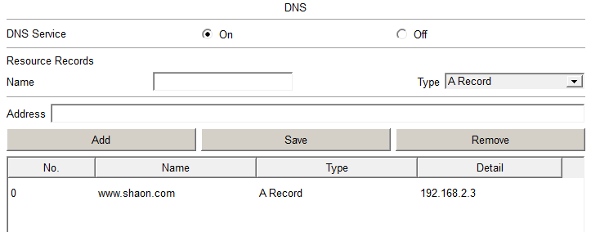
Figure 2: DNS resource record for www.shaon.com → 192.168.2.3
Server0 was configured as the HTTP/web server, hosting a simple page titled “Welcome to Shaon's Website”. PC0 was configured with an IP address on the 192.168.1.0/24 network, a default gateway of 192.168.1.1 (Router0's Fa0/0), and Server1's IP address set as its DNS server, so that it could resolve the domain name before requesting the page.

6. Output

6.1 Cisco Packet Tracer Design
The diagram below shows the completed topology inside Cisco Packet Tracer, including the interface labels used for cabling: Router0's Fa0/0 and Fa0/1 to the two switches, Switch0's Fa0/1 to PC0, and Switch1's Fa0/2 and Fa0/3 to the DNS server and web server respectively.

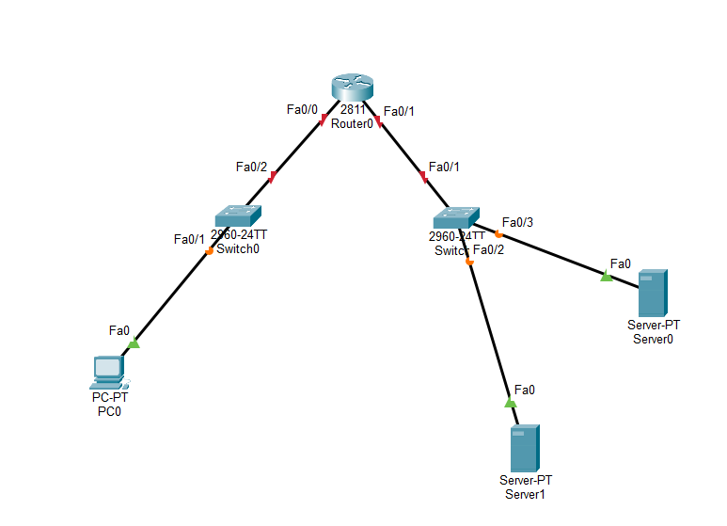
Figure 3: Final Packet Tracer topology

6.2 Output Result
From PC0's web browser, navigating to http://www.shaon.com successfully resolved the domain name through the DNS server and loaded the page hosted on the web server, confirming that routing, DNS resolution and HTTP service were all working end-to-end.
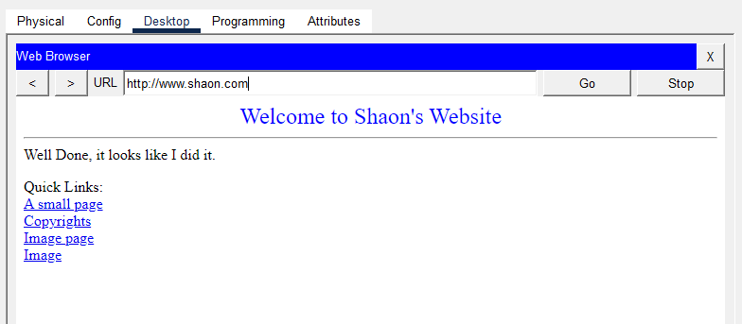
Figure 4: Web browser on PC0 successfully loading http://www.shaon.com

7. Observations
- Bringing up the router's FastEthernet interfaces with “no shutdown” was required before any IP address configuration would take effect; the LINK and LINEPROTO messages confirmed each interface was operational.
- Placing the PC and the servers on two separate subnets (192.168.1.0/24 and 192.168.2.0/24) meant the router had to actively route traffic between them; without correct interface IP addressing on Fa0/0 and Fa0/1, the PC would not have been able to reach the servers.
- The DNS A record (www.shaon.com → 192.168.2.3) was the key element that allowed the browser to use a friendly domain name instead of the web server's raw IP address.
- PC0 needed its DNS server field pointed at Server1 for name resolution to succeed — without this, the browser would only have worked using the web server's IP address directly.
- The successful load of “Welcome to Shaon's Website” in the browser confirmed that DNS resolution, IP routing between subnets, and the HTTP service were all functioning correctly together.
- This lab demonstrates the complete request path in a small network: client → default gateway (router) → DNS query/response → HTTP request to the resolved IP → web page rendered in the browser.

Jahangirnagar University
Institute of Information Technology
Savar, Dhaka-1342

Lab report - 06
VLAN Configuration and Inter-VLAN Routing

Course: Computer Networks Lab
Course Code: ICT-3104

Submitted To
Jesmin Akhter, PhD
Professor, Institute of Information Technology
Submitted By
Md. Shaon Khan
ID: 1984 Batch: 52 Session: 2022–2023

Date of Submission
20 July 2026

Background
A Virtual LAN (VLAN) lets a single physical switch (or set of switches) be split into several independent logical networks, each with its own broadcast domain. Devices placed in different VLANs behave as though they were on entirely separate switches, even if they share the same physical hardware and cabling. This report is organized in two parts to show the effect of VLANs on their own, and then the effect of adding a router. Part 1 configures VLANs on a single switch with no router present, so that devices in different VLANs are fully isolated from one another. Part 2 then reintroduces a router using the router-on-a-stick method, in which a single trunk link carries traffic for every VLAN and the router uses one sub-interface per VLAN (tagged with IEEE 802.1Q) to route between them, restoring communication between VLANs that Part 1 showed to be blocked.

Part 1 Without a Router: Basic VLAN Configuration

Objective
The goal of this part of the lab was defined as follows.
Objective: To create and configure VLANs on a Cisco switch, assign switch ports to the appropriate VLANs, and verify that devices within the same VLAN can communicate while devices in different VLANs cannot, in the absence of a Layer 3 routing device.

Topology Setup
- Switch model: Cisco 2960 Switch
- Number of PCs used: 4
- Cable type used to connect PCs to switch: copper straight-through cable

Network Diagram :

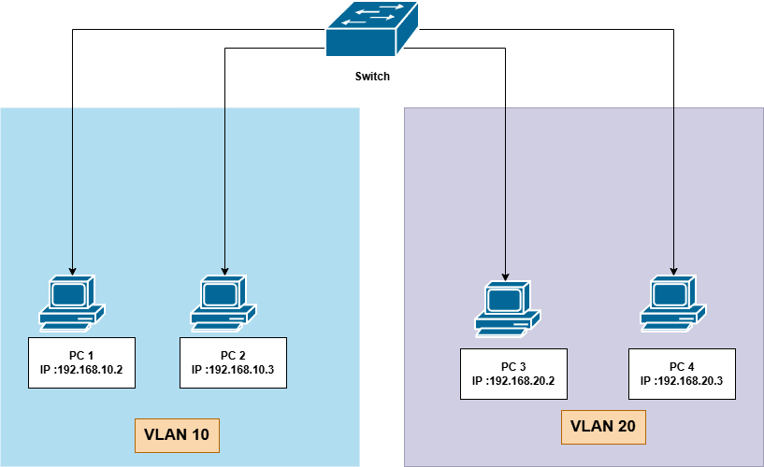

Step 1: Create VLANs
The following commands were entered from Switch > CLI to create VLAN 10 (Sales) and VLAN 20 (HR):
enable
configure terminal
vlan 10
name Sales
exit
vlan 20
name HR
exit

Step 2: Assign Ports to VLANs
The PC-to-VLAN-to-port mapping used for this lab is recorded in the table below, followed by the matching port configuration commands.
Device | VLAN | Switch Port
PC 1 | 10 | Fa0/1
PC 2 | 10 | Fa0/2
PC 3 | 20 | Fa0/3
PC 4 | 20 | Fa0/4

interface FastEthernet0/1
switchport mode access
switchport access vlan 10
exit
(repeat for each port)

Step 3: Assign IP Addresses to PCs
Device | IP Address | Subnet Mask | VLAN
PC 1 | 192.168.10.2 | 255.255.255.0 | 10
PC 2 | 192.168.10.3 | 255.255.255.0 | 10
PC 3 | 192.168.20.2 | 255.255.255.0 | 20
PC 4 | 192.168.20.3 | 255.255.255.0 | 20

Step 4: Verify VLAN
The verification command below was run to confirm the VLAN configuration, with the resulting output summarized underneath.
show vlan brief
Observations:
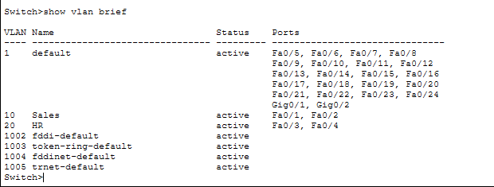
Running "show vlan brief" verified the port assignments: VLAN 10 (Sales) lists Fa0/1 and Fa0/2, and VLAN 20 (HR) lists Fa0/3 and Fa0/4, exactly as configured. Every other switch port remains in the default VLAN 1, showing that only the four ports intended for the lab were reassigned and nothing else was affected.

Output :
CISCO Configuration :
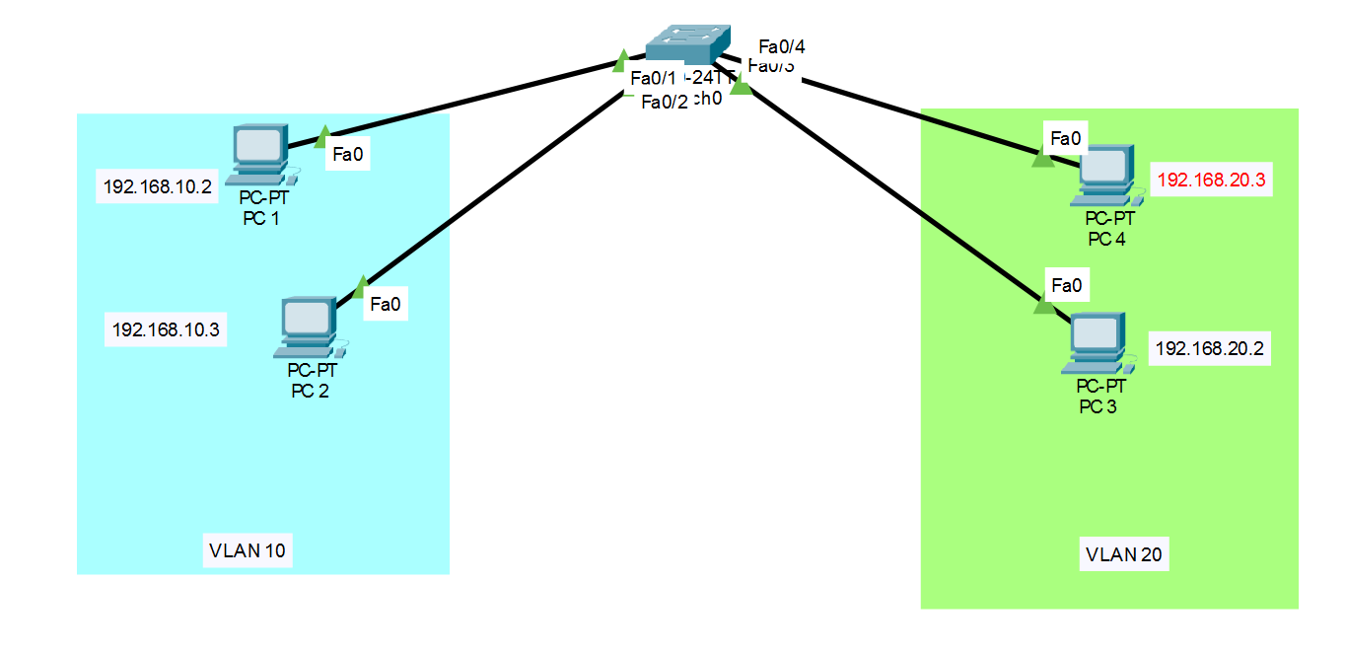

Same VLAN

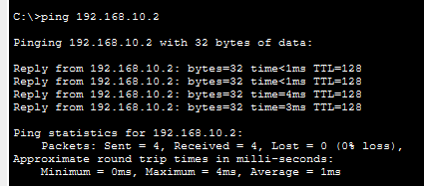

Observations:
PC 1 and PC 2 sit in the same VLAN (10), and the ping between them returned four replies with 0% loss. This is the expected result: both ports are in the same broadcast domain, so frames pass between them at Layer 2 with no need for any routing.

Different VLAN

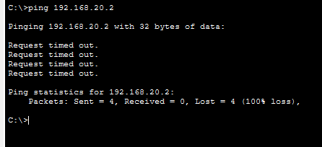

Observations:

PC 1 (VLAN 10) and PC 3 (VLAN 20) sit in different broadcast domains, and every ping attempt between them timed out (100% loss). This is expected in Part 1, since no Layer 3 device is present yet to route between VLANs; each VLAN behaves as an isolated network until routing is added, which is exactly what Part 2 introduces.

Part 2 With a Router: Inter-VLAN Routing (Router-on-a-Stick)
Building on Part 1, a router is now added to restore communication between VLAN 10 and VLAN 20 using the router-on-a-stick method. Each switch port facing a PC stays in access mode, while the single port facing the router is switched to trunk mode so that it can carry tagged traffic for both VLANs at once. On the router side, one sub-interface is created per VLAN, each tagged with IEEE 802.1Q ('encapsulation dot1q') and given an IP address that serves as the default gateway for that VLAN, allowing the router to route traffic between them over that one physical link.

Step 1: Draw the Network
The devices and connections used for this part of the topology are listed below:
Device | Interface | Connected To
Router | GigabitEthernet0/0 | Switch (Fa0/5, trunk)
Switch | Fa0/5 | Router (GigabitEthernet0/0, trunk)
Switch | Fa0/1 | PC 1
Switch | Fa0/2 | PC 2
Switch | Fa0/3 | PC 3
Switch | Fa0/4 | PC 4

Network Diagram :
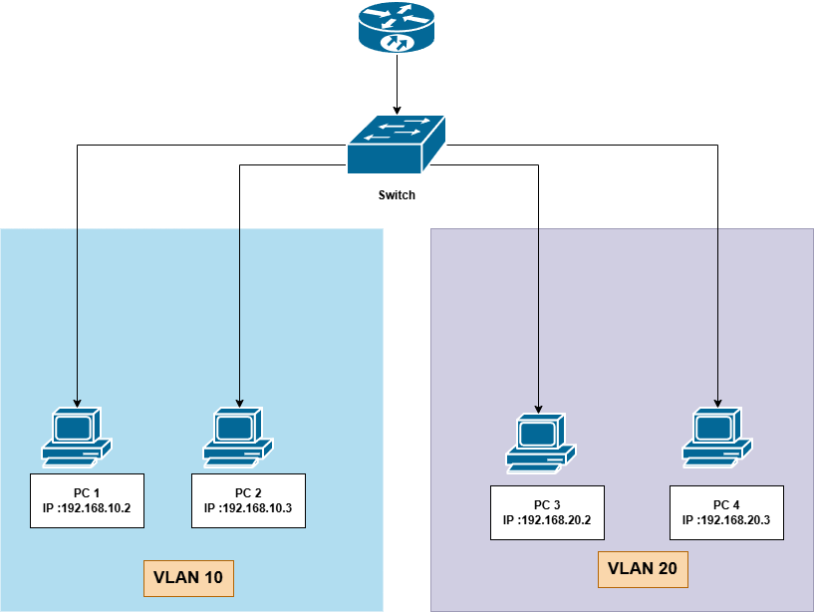
Step 2: Configure End Devices
Each PC/laptop was configured with the IP settings below, using the router sub-interface address as its default gateway.
Device | IPv4 Address | Subnet Mask | Default Gateway | VLAN
PC 1 | 192.168.10.2 | 255.255.255.0 | 192.168.10.1 | 10
PC 2 | 192.168.10.3 | 255.255.255.0 | 192.168.10.1 | 10
PC 3 | 192.168.20.2 | 255.255.255.0 | 192.168.20.1 | 20
PC 4 | 192.168.20.3 | 255.255.255.0 | 192.168.20.1 | 20

Step 3: Configure the Switch
Create VLANs, assign access ports, and set the uplink port to trunk mode.
Switch>enable
Switch#configure terminal
Switch(config)#vlan 10
Switch(config-vlan)#name Sales
Switch(config-vlan)#exit
Switch(config)#vlan 20
Switch(config-vlan)#name HR
Switch(config-vlan)#exit
Switch(config)#interface FastEthernet0/1
Switch(config-if)#switchport mode access
Switch(config-if)#switchport access vlan 10
Switch(config-if)#exit
(repeat for Fa0/2 with vlan 10, and Fa0/3, Fa0/4 with vlan 20)
Switch(config)#interface FastEthernet0/5
Switch(config-if)#switchport mode trunk
Switch(config-if)#end

Step 4: Configure the Router
Bring up the physical interface, then create one sub-interface per VLAN with dot1q encapsulation and an IP address that will act as the default gateway for that VLAN.
Router>enable
Router#configure terminal
Router(config)#interface GigabitEthernet0/0
Router(config-if)#no shutdown
Router(config-if)#exit
Router(config)#interface GigabitEthernet0/0.10
Router(config-subif)#encapsulation dot1q 10
Router(config-subif)#ip address 192.168.10.1 255.255.255.0
Router(config-subif)#exit
Router(config)#interface GigabitEthernet0/0.20
Router(config-subif)#encapsulation dot1q 20
Router(config-subif)#ip address 192.168.20.1 255.255.255.0
Router(config-subif)#exit
Router(config)#end

Step 5: Verify Configuration
The command below was run on the switch to verify the configuration, with the observations recorded underneath.
Switch>show vlan brief
Output :
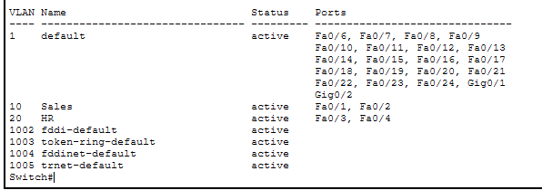

CISCO Configuration :
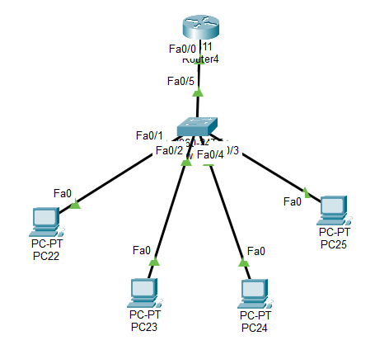

Observations:
The "show vlan brief" output still shows VLAN 10 (Sales) and VLAN 20 (HR) with their original access ports (Fa0/1-Fa0/2 and Fa0/3-Fa0/4). Fa0/5, the port now facing the router, no longer appears under either VLAN's port list; this is the expected behaviour for a trunk port, since it carries tagged traffic for all VLANs rather than belonging to just one of them.
Ping test between VLAN
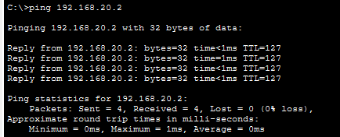
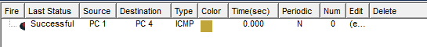
With the router-on-a-stick configuration in place, pinging from PC 1 (192.168.10.2, VLAN 10) to PC 3 (192.168.20.2, VLAN 20) now completes successfully with 0% packet loss. Traffic from PC 1 reaches its VLAN 10 gateway (192.168.10.1), crosses the trunk link tagged for VLAN 10, gets routed by the sub-interfaces to VLAN 20, and is delivered to PC 3 – the exact path that was missing in Part 1.

Conclusion

Summary of findings from both parts of this lab.
Part 1 configured VLAN 10 (Sales) and VLAN 20 (HR) on a single switch with no router present. The ping tests showed the two sides of VLAN behaviour clearly: PC 1 and PC 2, both in VLAN 10, communicated with 0% loss, while PC 1 and PC 3, split across VLAN 10 and VLAN 20, could not reach each other at all (100% loss). This confirmed that each VLAN is its own isolated broadcast domain until something is added to route between them.
Part 2 reintroduced a router using router-on-a-stick over a single trunk link, with one sub-interface per VLAN handling 802.1Q-tagged traffic. That single change reversed the earlier result: the same PC 1-to-PC 3 ping that had failed in Part 1 now succeeded with 0% packet loss, confirming that the router was routing correctly between VLAN 10 and VLAN 20.
Taken together, the two parts of this lab show a clear before-and-after: VLANs alone improve organization and security by isolating broadcast traffic into separate domains, but they also cut off inter-VLAN communication by design; router-on-a-stick is what restores that connectivity when it is needed, without requiring a separate physical link for each VLAN. No major issues were encountered once the access/trunk port modes and the sub-interface encapsulation on the router were configured correctly.

Jahangirnagar University
Institute of Information Technology
Savar, Dhaka-1342

Lab report - 07
VLAN and Trunking Configuration Across Multiple Switches

Course: Computer Networks Lab
Course Code: ICT-3104

Submitted To
Jesmin Akhter, PhD
Professor, Institute of Information Technology
Submitted By
Md. Shaon Khan
ID: 1984 Batch: 52 Session: 2022–2023

Date of Submission
20 July 2026

1. Objective
The objective of this lab is to configure Virtual LANs (VLANs) and trunk links across three interconnected Cisco 2960-24TT switches in Cisco Packet Tracer. Three VLANs (10, 20 and 30) are created to segment the PCs into separate broadcast domains regardless of which physical switch they are connected to, and 802.1Q trunk links are configured between the switches so that VLAN traffic can be carried between them. The lab then verifies that PCs in the same VLAN can communicate across switches through the trunks, while PCs in different VLANs remain isolated from one another.

2. Setup
The topology consists of three Cisco 2960-24TT switches – Switch1 (top/central), Switch2 (bottom-left) and Switch3 (bottom-right) – interconnected in a triangular arrangement using trunk links: Switch1 – Switch2 (Fa0/7 – Fa0/8), Switch1 – Switch3 (Fa0/8 – Fa0/8), and Switch2 – Switch3 (Fa0/7 – Fa0/7). A total of sixteen PCs (PC26 – PC43) are connected to the access ports of the three switches, distributed across VLAN 10, VLAN 20 and VLAN 30 as shown in the logical diagram, so that every VLAN has member PCs spread across more than one physical switch.
VLAN ID | Name | Purpose | Typical Ports (per switch)
10 | Sh | PC group 1 | Fa0/1, Fa0/2
20 | Ao | PC group 2 | Fa0/3, Fa0/4
30 | Kh | PC group 3 | Fa0/5, Fa0/6

The same three VLANs (10 = Sh, 20 = Ao, 30 = Kh) were created identically on all three switches so that a PC in, for example, VLAN 10 on Switch2 is in the same broadcast domain as a PC in VLAN 10 on Switch3, with the trunk links carrying the tagged VLAN traffic between switches.

3. Network Diagram (draw.io)
The logical diagram below, produced in draw.io, shows how the PCs are distributed across VLAN 10, VLAN 20 and VLAN 30, and how each PC connects into one of the three interconnected switches – illustrating that VLAN membership is independent of which physical switch a PC is plugged into.
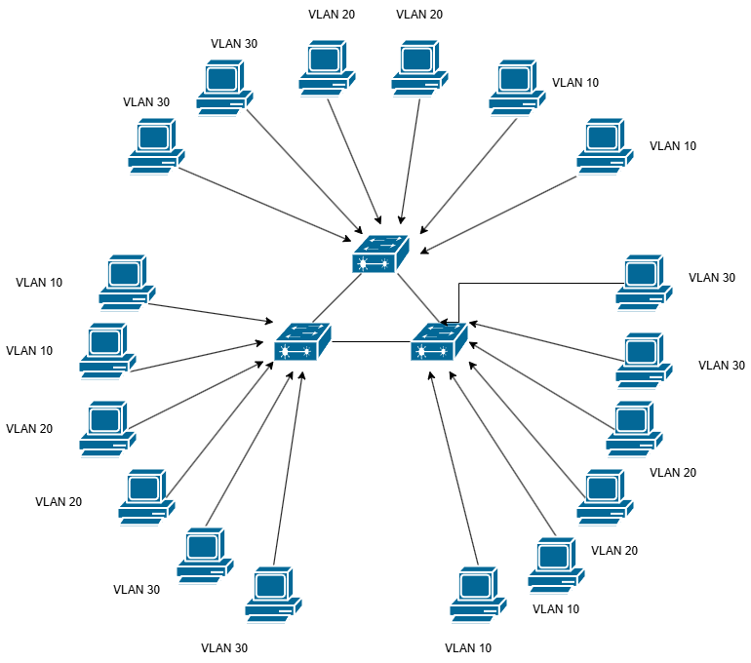
Figure 1: Logical VLAN diagram (draw.io)

4. Switch CLI Configuration
On each switch, VLANs 10, 20 and 30 were created and named, the access ports were assigned to their respective VLANs, and the inter-switch links were configured as trunk ports so that all VLANs could pass between switches. The configuration applied on each of the three switches was as follows:
Switch>enable
Switch#configure terminal
Switch(config)#vlan 10
Switch(config-vlan)#name Sh
Switch(config-vlan)#exit
Switch(config)#vlan 20
Switch(config-vlan)#name Ao
Switch(config-vlan)#exit
Switch(config)#vlan 30
Switch(config-vlan)#name Kh
Switch(config-vlan)#exit
Switch(config)#interface range fa0/1-2
Switch(config-if-range)#switchport mode access
Switch(config-if-range)#switchport access vlan 10
Switch(config-if-range)#exit
Switch(config)#interface range fa0/3-4
Switch(config-if-range)#switchport mode access
Switch(config-if-range)#switchport access vlan 20
Switch(config-if-range)#exit
Switch(config)#interface range fa0/5-6
Switch(config-if-range)#switchport mode access
Switch(config-if-range)#switchport access vlan 30
Switch(config-if-range)#exit
Switch(config)#interface range fa0/7-8
Switch(config-if-range)#switchport mode trunk
Switch(config-if-range)#exit

After configuration, “show vlan brief” was run on each switch to confirm that VLANs 10, 20 and 30 were active and mapped to the correct access ports. The identical output on all three switches confirms the VLAN configuration was applied consistently across the network.
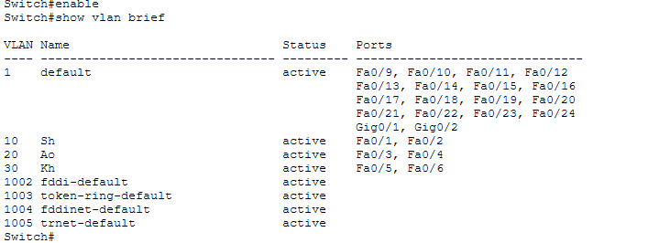
Figure 2: show vlan brief – Switch1
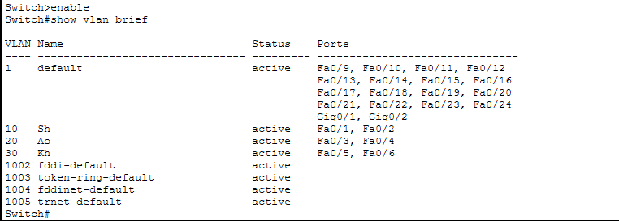
Figure 3: show vlan brief – Switch2
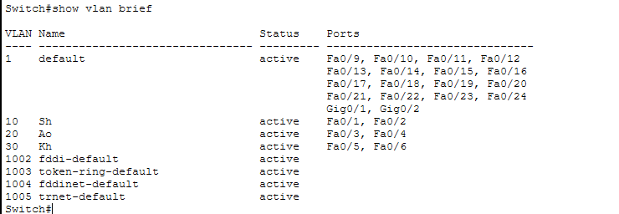
Figure 4: show vlan brief – Switch3

5. Output

5.1 Cisco Packet Tracer Design
The diagram below shows the completed topology inside Cisco Packet Tracer: Switch1 at the top connects to sixteen PCs (PC38 – PC43) directly and to Switch2 and Switch3 via trunk links (Fa0/7/Fa0/8); Switch2 and Switch3 each connect a further group of PCs (PC26 – PC31 and PC32 – PC37 respectively) and are also trunked directly to one another.

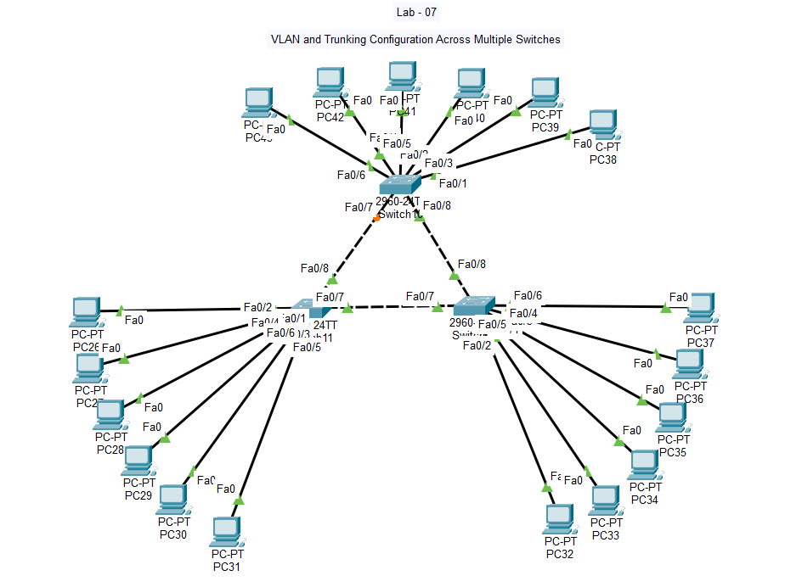
Figure 5: Final Packet Tracer topology – VLAN and Trunking Configuration Across Multiple Switches

5.2 Output Result
Two ping tests were carried out from a PC's command prompt to verify VLAN behaviour across the trunked switches. Pinging 192.168.1.7, a host belonging to the same VLAN as the source PC but attached to a different switch, succeeded with 0% packet loss – confirming that the trunk links correctly carried tagged traffic for that VLAN between switches.
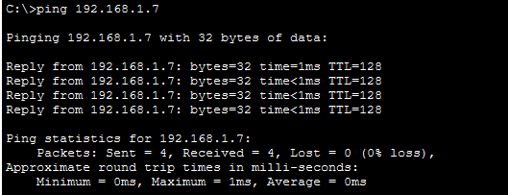
Figure 6: Successful ping to 192.168.1.7 (same VLAN, different switch)
Pinging 192.168.1.8, a host belonging to a different VLAN, resulted in 100% packet loss (“Request timed out” for all four packets) – confirming that hosts in different VLANs are isolated from one another at Layer 2 and cannot communicate without an inter-VLAN routing device (such as a router-on-a-stick or Layer 3 switch), which was not configured in this lab.
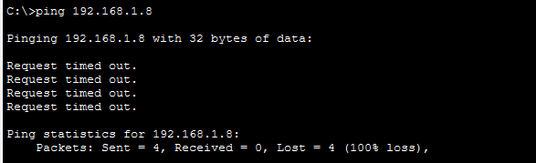
Figure 7: Failed ping to 192.168.1.8 (different VLAN – isolated)

6. Observations
- Creating the same VLANs (10 = Sh, 20 = Ao, 30 = Kh) with matching names on all three switches was essential for VLAN membership to remain consistent network-wide, regardless of which switch a PC was physically connected to.
- Configuring the inter-switch links (Fa0/7 and Fa0/8) as trunk ports rather than access ports allowed all three VLANs to pass between switches over a single physical link, using 802.1Q tagging.
- The “show vlan brief” command was a useful verification step, confirming the VLAN-to-port mapping was identical across Switch1, Switch2 and Switch3 before any connectivity testing was done.
- A successful ping to 192.168.1.7 demonstrated that trunking worked correctly – two PCs in the same VLAN but on different physical switches could communicate as if they were on the same local segment.
- A failed ping (100% loss) to 192.168.1.8 demonstrated that VLANs correctly separate broadcast domains – PCs in different VLANs could not reach each other, since no Layer 3 device was configured to route between VLANs.

Jahangirnagar University
Institute of Information Technology
Savar, Dhaka-1342

Lab report - 08
Configuration of an Email Server (SMTP/POP3)

Course: Computer Networks Lab
Course Code: ICT-3104

Submitted To
Jesmin Akhter, PhD
Professor, Institute of Information Technology
Submitted By
Md. Shaon Khan
ID: 1984 Batch: 52 Session: 2022–2023

Date of Submission
20 July 2026

1. Objective
The purpose of this lab is to design and simulate a small Local Area Network (LAN) in Cisco Packet Tracer and configure an Email Server capable of providing SMTP (mail sending) and POP3 (mail receiving) services. The lab also aims to verify email communication between two client PCs connected to the same network by sending and receiving messages through the configured mail server.
Specifically, the objectives of this lab are to:
- Design a basic LAN topology consisting of a server, a switch, and two client PCs.
- Assign appropriate static IP addresses to all network devices.
- Configure the Email (SMTP/POP3) service on the server, including domain name and user accounts.
- Configure email clients on PC1 and PC2 to send and receive mail through the server.
- Verify successful email delivery by observing the Mail Browser output on the receiving PC.

2. Setup / Network Diagram
The network was designed using draw.io to plan the logical topology before implementing it in Cisco Packet Tracer. The topology consists of one Server, one Switch, and two PCs (PC1 and PC2), all connected within the same subnet (192.168.1.0/24).
Device | IP Address
Server (Email Server) | 192.168.1.10
PC1 | 192.168.1.11
PC2 | 192.168.1.12
Subnet Mask | 255.255.255.0

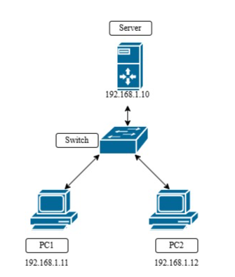
Figure 1: Network Diagram (draw.io) — Server, Switch, PC1 and PC2 with assigned IP addresses
As shown in Figure 1, the Server (192.168.1.10) connects directly to the Switch, which in turn connects to PC1 (192.168.1.11) and PC2 (192.168.1.12). All devices reside on the same broadcast domain, which is a requirement for the email service to function correctly without needing routing or DNS forwarding.
This logical design was then implemented in Cisco Packet Tracer using a generic Server-PT (Server6), a 2960-24TT Switch (Switch1), and two Generic PCs (PC44 and PC45). Server6 connects to the switch's Fa0/3 port, while PC44 and PC45 connect to Fa0/1 and Fa0/2 respectively, each through its own Fa0 interface.
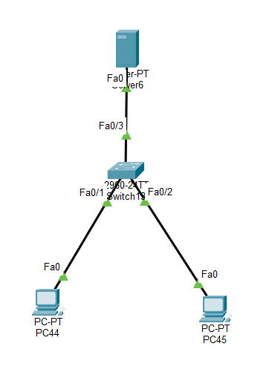
Figure 2: Actual network topology implemented in Cisco Packet Tracer - Server6, Switch1 (2960-24TT), PC44, and PC45

3. Email Server Configuration in a LAN
On the Server, the Email service was enabled under Config → SERVICES → EMAIL. Both the SMTP Service and POP3 Service were switched ON so the server could handle outgoing (SMTP) and incoming/retrieval (POP3) mail requests.
The Domain Name was set to gmail.com, and two user accounts were created under User Setup to represent the two mail clients:
Username | Password
shaon | 1234
phyra | 12345

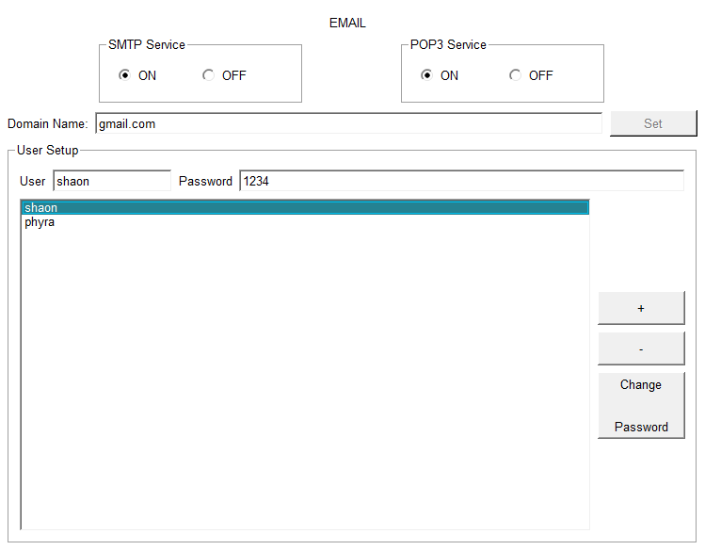
Figure 3: Email Service configuration on the Server — SMTP/POP3 set to ON, domain name gmail.com, and user accounts (shaon, phyra)
After the domain and user accounts were set, each client PC's Desktop → E Mail application was configured with the corresponding username, matching email address (e.g., shaon@gmail.com, phyra@gmail.com), and the server's IP address (192.168.1.10) as both the incoming (POP3) and outgoing (SMTP) mail server.

4. PC Output: Cisco Design Output Result
With the server and clients configured, an email exchange was tested between the two PCs to validate the setup.

4.1 Sending Mail from PC44 (phyra@gmail.com)
PC44 composed and sent a message with the subject "Hello" to shaon@gmail.com. The Mail Browser on PC44 shows the sent message logged with the timestamp Fri Jul 17 2026 16:55:38, and the status bar confirms the client was receiving mail from the POP3 Server at 192.168.1.10, indicating successful communication with the mail server.

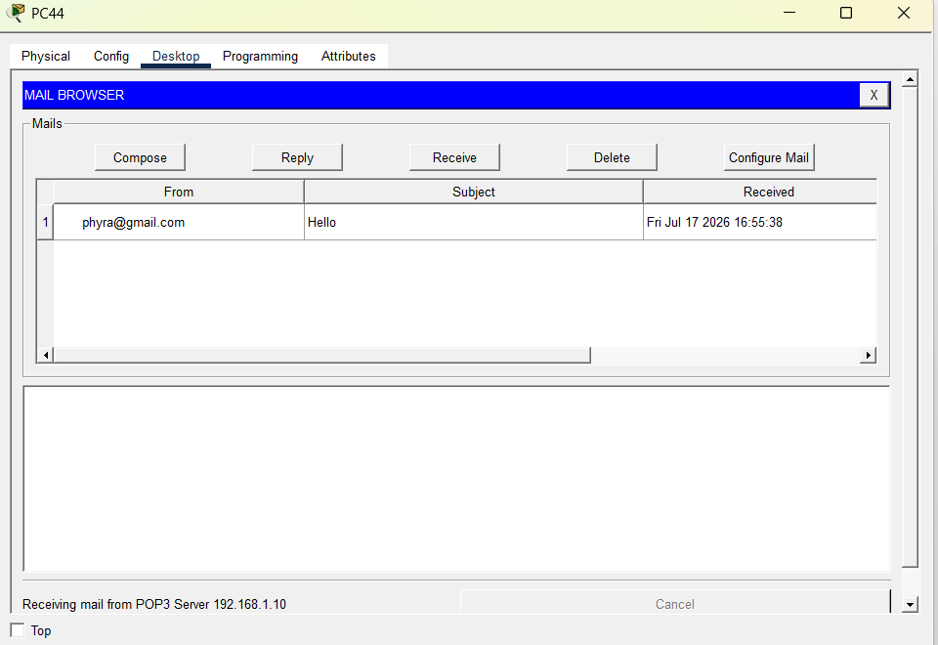
Figure 4: PC44 Mail Browser — message "Hello" sent to shaon@gmail.com

4.2 Receiving and Replying on PC45 (shaon@gmail.com)
On PC45, clicking Receive successfully retrieved the message "RE: Hello" from the server, confirming the reply had been delivered. The Mail Browser log shows the reply received at Fri Jul 17 2026 16:56:25, quoting the original message from phyra@gmail.com sent at 16:55:38. The status bar displays "Receiving mail from POP3 Server 192.168.1.10" followed by "Receive Mail Success," confirming that the POP3 retrieval completed without errors.
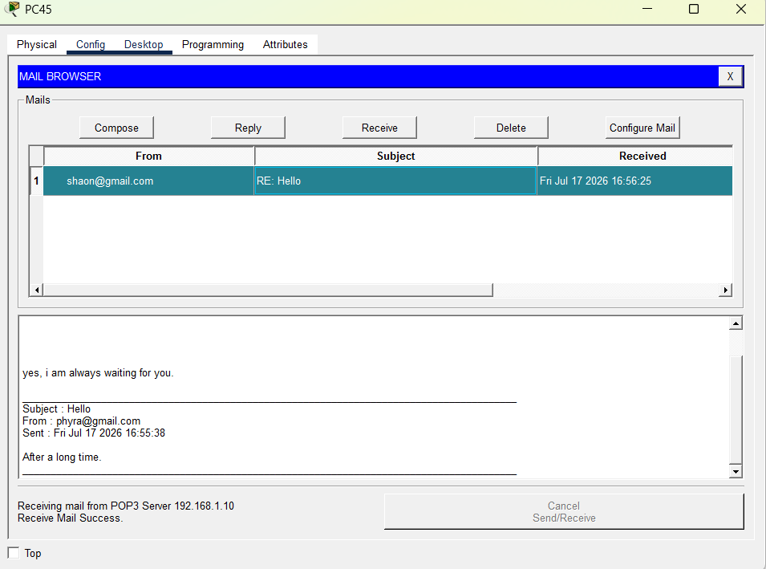
Figure 5: PC45 Mail Browser — reply received successfully, with the original message thread visible

5. Observations
- Placing the Server, Switch, and both PCs on the same subnet (192.168.1.0/24) allowed the email service to function correctly without requiring a router or DNS server.
- Enabling both SMTP and POP3 services on the server was necessary — SMTP handled outgoing mail submission, while POP3 handled the clients' retrieval of incoming mail.
- Each client's email address had to match the domain name configured on the server (gmail.com) and a user account had to exist on the server for delivery to succeed.
- The status bar message "Receiving mail from POP3 Server 192.168.1.10" together with "Receive Mail Success" on PC45 confirmed that the POP3 protocol exchange between client and server completed correctly.
- The reply thread on PC45 correctly quoted the original message from PC44, demonstrating that the mail server properly stored and forwarded message content and headers (From, Subject, Sent date).
- The entire exchange (send from PC44, receive and reply from PC45) completed within about one minute of simulated time, showing that Packet Tracer's simulated SMTP/POP3 exchange behaves as expected for a small LAN mail setup.

6. Conclusion
The lab successfully demonstrated the design and configuration of a basic LAN-based email system in Cisco Packet Tracer. By configuring static IP addressing, enabling SMTP and POP3 services on the server, and setting up matching user accounts on the mail clients, two PCs were able to exchange email messages reliably within the local network.

Jahangirnagar University
Institute of Information Technology
Savar, Dhaka-1342

Lab report - 09
Connect end devices using Access Point

Course: Computer Networks Lab
Course Code: ICT-3104

Submitted To
Jesmin Akhter, PhD
Professor, Institute of Information Technology
Submitted By
Md. Shaon Khan
ID: 1984 Batch: 52 Session: 2022–2023

Date of Submission
20 July 2026

1. Objective
To understand the role of an Access Point in a wireless LAN (WLAN) by connecting end devices, configuring SSID and security settings, obtaining IP addresses, and verifying connectivity using network testing tools such as ping or simulation.

2. Apparatus
- Cisco Packet Tracer
- End devices: PCs, Laptop, and Mobile (Smartphone)

3. Network Diagram
The wireless topology consists of one Access Point (AccessPoint-PT-AC, Access Point0) providing connectivity to four wireless end devices: a PC, two Laptops, and a Smartphone. All devices are associated with the Access Point and addressed within the same subnet.
Device | IP Address
PC0 | 192.168.1.10
Laptop0 | 192.168.1.11
Laptop1 | 192.168.1.12
Smartphone0 | 192.168.1.13

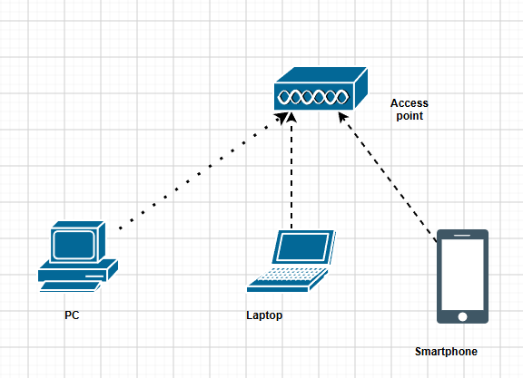
Figure 1.1: Logical wireless network diagram (draw.io)
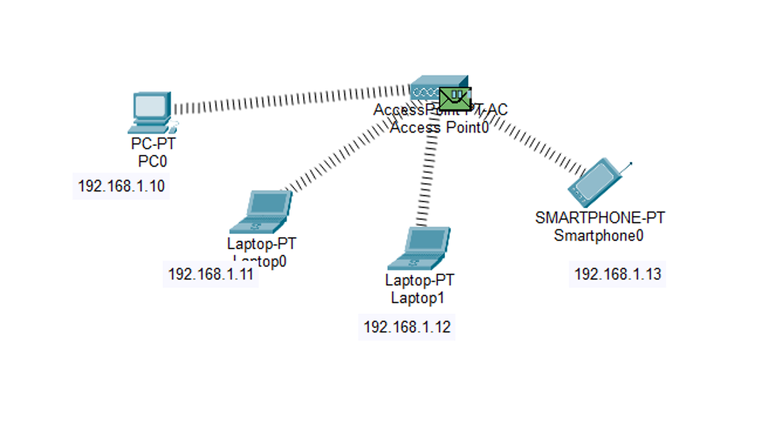
Figure 1.2: Wireless network topology — PC0, Laptop0, Laptop1, and Smartphone0 connected wirelessly through Access Point0

4. Procedure
1. Open Cisco Packet Tracer and build the network topology as shown in the network diagram. Place the required devices in the workspace: 1 Access Point, 2 PCs or more, 1 Laptop, and 1 Cell phone.
2. Configure the Access Point by assigning an SSID (network name) and, if required, enable WPA2-PSK security with a password to secure the wireless network.
3. If using a wireless PC or Laptop, install a wireless network adapter (if needed) and connect it to the SSID.
4. Connect the end device to the wireless network by opening its wireless settings, selecting the configured SSID, and entering the password if security is enabled.
5. Configure the IP addressing for the connected devices by either enabling DHCP to obtain IP addresses automatically or assigning static IP addresses that belong to the same network.
6. Test network connectivity by opening the Command Prompt on one device and using the ping command to send ICMP packets to the IP address of another connected device. Observe the ping results and confirm that the devices can successfully communicate through the Access Point, indicating that the wireless network has been configured correctly.

5. Output
Connectivity between the wireless devices was verified in Simulation Mode by sending an ICMP packet from PC0 to Laptop0. The sequence below shows the packet leaving PC0, being processed by the Access Point, and arriving at the destination.
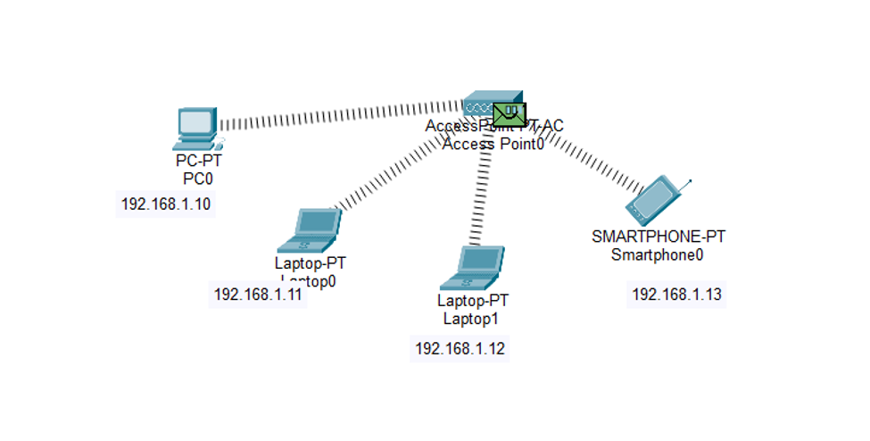
Figure 2: ICMP packet generated at each connected device and queued for transmission through Access Point0
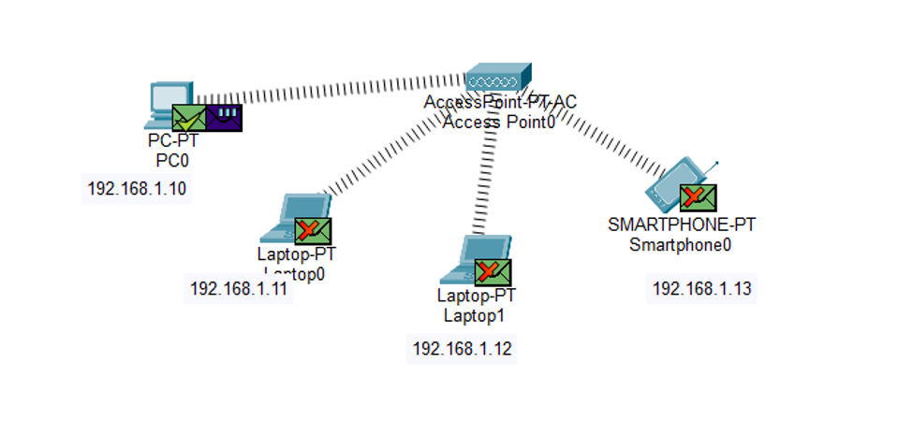
Figure 3: Packet in transit — envelope icon shown at Access Point0 as it forwards the ICMP request toward the destination device
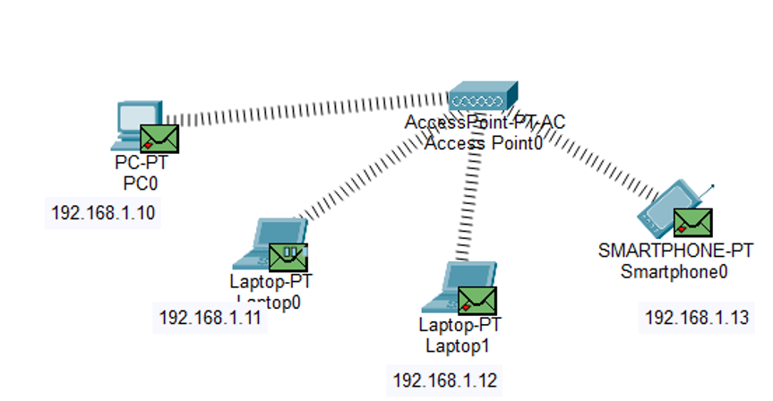
Figure 4: Packet send from PC to Laptop — ICMP request traveling from PC0 through Access Point0 to Laptop0
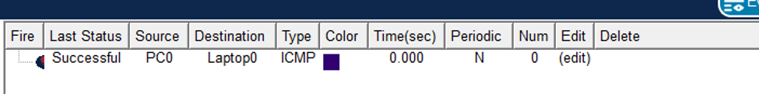
Figure 5: PDU list showing the ping result — Source: PC0, Destination: Laptop0, Type: ICMP, Last Status: Successful
The PDU List Window (Figure 5) confirms the outcome of the simulation: the ICMP packet sent from PC0 to Laptop0 completed with a Last Status of Successful, verifying that both devices obtained valid IP addresses on the same subnet and that the Access Point correctly forwarded traffic between them.

6. Observations
- All four end devices (PC0, Laptop0, Laptop1, Smartphone0) associated successfully with Access Point0 using the configured SSID, confirming that the wireless link layer was established correctly.
- Assigning each device an IP address within the same subnet (192.168.1.0/24) was essential for the devices to communicate through the Access Point without requiring a router.
- The Access Point functioned purely as a Layer 2 bridge between the wireless medium and the connected devices, forwarding frames without performing any routing.
- The Simulation Mode animation clearly showed the ICMP request propagating outward from PC0 through the Access Point before reaching Laptop0, illustrating how a wireless access point relays traffic between associated stations.
- The PDU List Window recorded a Last Status of Successful for the PC0-to-Laptop0 ping, confirming end-to-end connectivity across the wireless network.
- Enabling WPA2-PSK security (where configured) did not affect connectivity once all devices were supplied with the matching passphrase, showing that authentication and IP-level communication operate independently once association succeeds.

7. Conclusion
This lab demonstrated the fundamental role of an Access Point in a wireless LAN: providing a shared medium through which multiple wireless stations — a PC, laptops, and a smartphone — can associate, obtain addressing, and exchange traffic. By configuring the SSID, addressing each device within a common subnet, and verifying connectivity with an ICMP ping, the successful PDU result confirmed that the wireless network was configured and operating correctly.

